Answer Book
Workbook 3 – Furnishing
Read the question from the workbook and type your answer in the places shown in this worksheet., or follow the individual instructions given in the question. The summary (only) of the question is provided here. The workbook has the full details.
Basic Construction
Q1/. Joints – Types and uses – Page 2
Type for a
Type for b
Type for c
Use for a
Use for b
Use for c

Q2/. Joints – Types and uses – Page 1
Type for a
Type for b
Type for c
Type for d
Use for a
Use for b
Use for c
Use for d

Q3/. Construction joints and uses – Page 2
Type for a
Type for b
Type for c
Use for a
Use for b
Use for c

Q4/. Construction joints and uses – Page 2
Type for a
Type for b
Type for c
Type for d
Use for a
Use for b
Use for c
Use for d

Q5/. Construction joints and uses – Page 3
Type for a
Type for b
Type for c
Use for a
Use for b
Use for c
Q6/. Construction joints and uses – Page 3
Type for a
Type for b
Type for c
Use for a
Use for b
Use for c

Q7/. Construction joints and uses – Page 3
Type for a
Type for b
Type for c
Use for a
Use for b
Use for c

Q7/. Construction joints and uses – Page 4
Type for a
Type for b
Type for c
Type for d
Use for a
Use for b
Use for c
Use for d

Basic Assembly – Page - 4
Q1/. Choice of adhesive

Q2/. Assembly planning - Page 4
(highlight the correct answer)
a b c d
Q3/. Face and Edge Marks - Page 4
(Hand draw the frame and in pen or pencil show the answer. Put you name on the paper and hand it in.
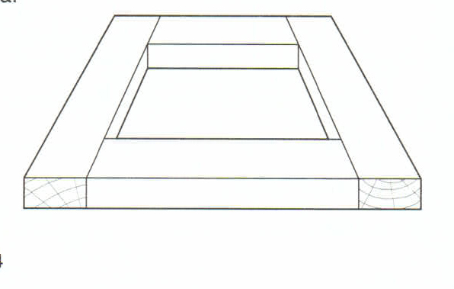

Q4/. Which does not apply to the face and edge marks. (highlight the correct answer). – Page 5
a b c d

Q5/. Glue coats – Page 5

Q6/. Adhesives - Page 5

Q7/. PVA Glue working time (highlight the correct answer) – Page 5
a b

Q8/. Tools Assembly Operations (highlight the correct answer) – Page 5
a b c d e f

Q9/. Cramping Equipment Preparation – Page 4

Q10/. Complete the sentence on assembly operations – Page 5
During assembly operations pressure should be applied and on all cramps to avoid unnecessary in the frame and on the joints.

Q11/. PVA Glue Minimum cramping time. (highlight the correct answer) – Page 5
a b c d

Q12/. Poorly fitted joints. – Page 6

Q13/. Nailed/screwed joints (highlight the correct answer) – Page 6
a b

Q14/. Solid timber table cramped – Page 6

Q15/. Blocks of wood in cramping – Page 6

Q16/. Tapered frame (highlight the correct answer) – Page 6
a b c d
Q17/. Checked for square – Page 7

Q18/. Square a cramped frame (highlight the correct answer) – Page 7
a b
Q19/. Positioning of cramps – Page 7

Q20/. Trade term (highlight the correct answer) – Page 7
a b c d

Q21/. Timber faces twisted statement (highlight the correct answer) – Page 7
a b c d

Q22/. Keep frames flat – Page 7

Q23/. Frame in wind (highlight the correct answer) – Page 7
a b

Time Efficiency
Q1/. Time efficiency can be broadly described as:

Q2/. Making preparations, (highlight the correct answer).
a b c d

Q3/. Complete the sentence:
Production assembly methods should be designed to use as little of the available as possible.

Drawing – Page 8
Drawing as a means of communication.
Q1/. Complete the following sentence:
A furniture designer must have graphic skills so that detailed can be prepared to accurately convey design and information to workshop personnel.
Q2/. Freehand sketches (highlight the correct answer).
a b c d
Q3/. Formal pictorial drawings use (three instances):

Q4/. Name the three common types of pictorial drawings used in the examples. – Page 9
A
B
C

Q5/. Working drawings. – Page 9
A
B
C
D

Q6/. Full sized set-outs use. – Page 9
A
B

7/. Complete the missing spots in the table. – Page 9
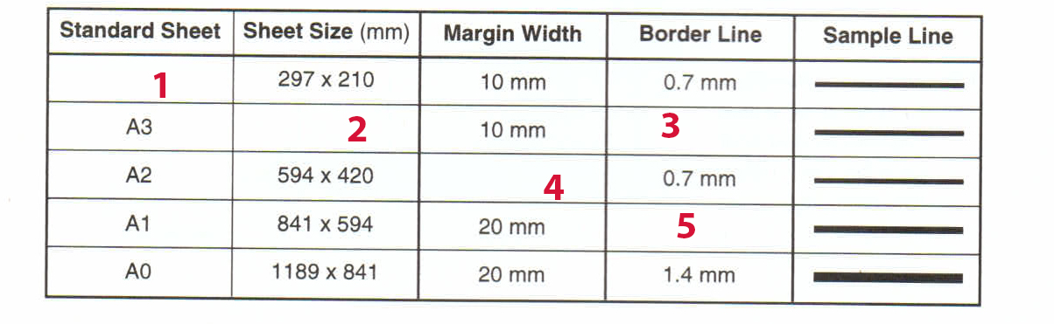
1 | 2 | 3 | 4 | 5

8/. Basic title block for a working drawing – Page 10
A
B
C
D
E

9/. Line types – Page 10
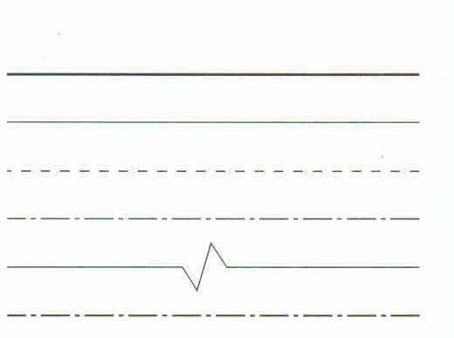

1
2
3
4
4
5

Q10/. Complete the table – Page 10
1 | 2 | 3 | 4 | 5

Q11/. Dimensioning Lines – Page 10. For these questions use the hand drawing sheet provided.
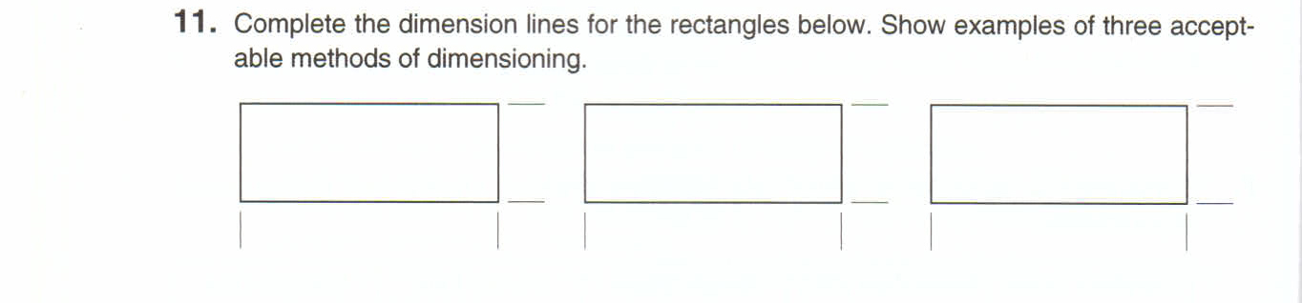
1 2 3
Length – use draw arrows
Height – use draw arrows

Q12/. Standard hatching
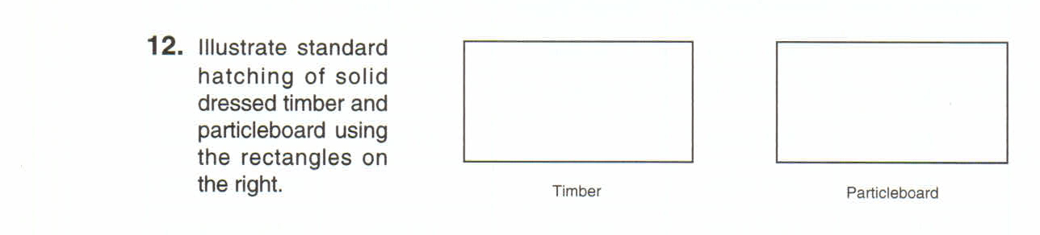
Google for your answers and place your images in the table below:
Solid Dressed Timber | Particleboard

Q13/. Complete your answers on the next page, in the space provided. 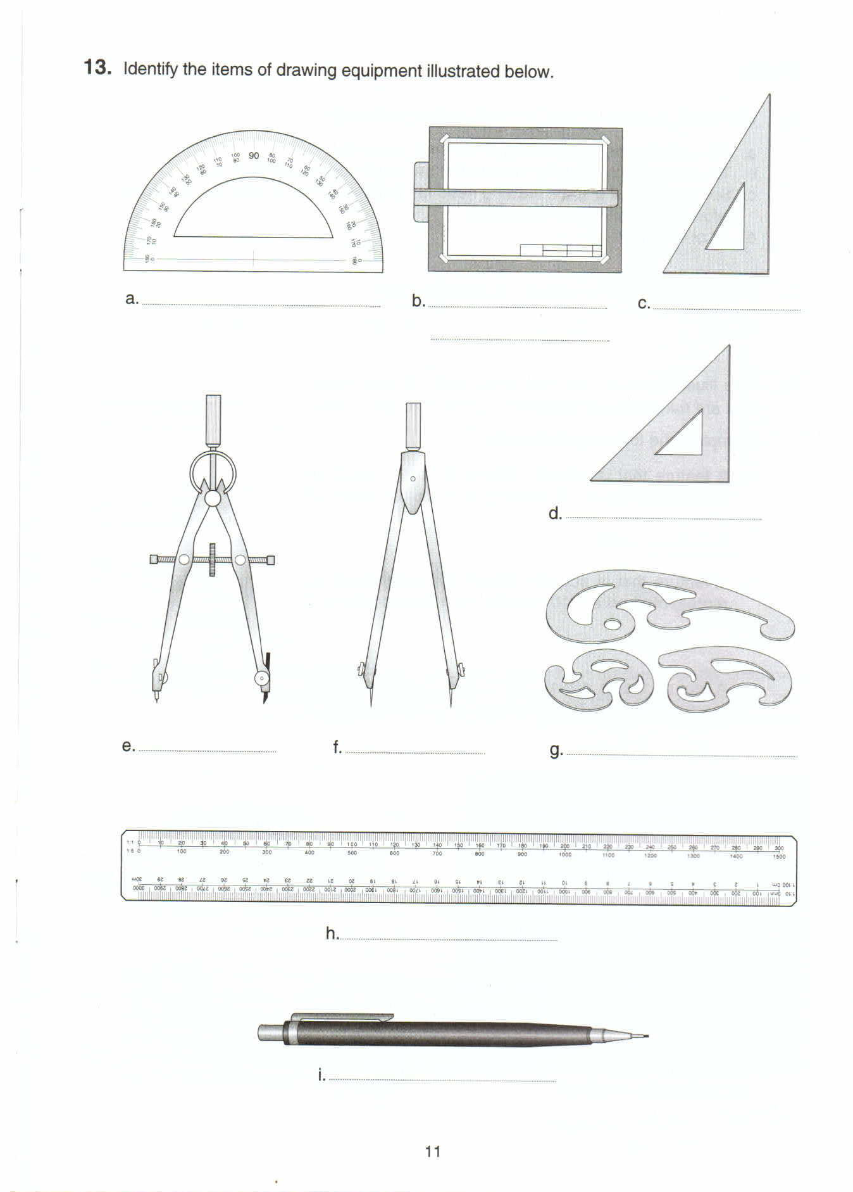

Q13/. Answers – Page 11
A
B
C
D
E
F
G
H
I

Scales – Page 12
Q1/. Scale working drawings (highlight the correct answer).

a b c d

Q2/ Scale reduction ratio (highlight the correct answer).
a b c d

Q3/. Use the illustrations in the .pdf file and complete the answers:
A
B
C

Q4/. Grid (There is a handout grid sheet for this) – Pages 12 (and 13 for the grid).

8

7

6

5

4

3

2

1

0 | A | B | C | D | E | F | G | H | I | J | K

Working Drawings – Page 13 14 – 15 – 16 – Using/Learning Sketchup .
Q1/. Refer to the image on page 13.
Draw the cabinet using the dimension shown, using Sketchup.

Q2/. Refer to the dimensions on page 14 and the view projections. – Page 14.
Draw the joint construction using Sketchup.

Q3/. Complete the two joints allowing the four pieces to fit together as two joints, using Sketchup. – Page 15.

Q4/. Reproduce the drawing shown in Sketchup, using a scale of 1:5. – Page 15.

Q5/. Carry-All. – Page 16.
Draw the front, side and top views on a scale of 1:2, using Sketchup.

Q6/. Draw an exploded isometric view in line for the assembly, using Sketchup.

Freehand Sketching – Page 17.
1/. What are the advantages of freehand sketching.
A
B
C
D

2/. Freehand pictorial sketch of a single dovetail joint, using Sketchup. – Page 18.
Save the Sketchup drawing as 17.2
3/. Draw working drawings for your next workshop project, in Sketchup. – Page 18.
Save the Sketchup drawing as 17.3
4/. Draw a sketch of a construction joint in Sketchup. – Page 19.
Save the Sketchup drawing as 17.4

Full- Size Set-Outs - Page 19.
Q1/. List two factors which illustrate the importance of full-sized set-outs.
A
B

Q2/. Complete one of the exercises, using Sketchup. – Page 19.
Save the file in Sketchup as 19.0

Workplace Environment. – Page 20.
Management and Control
Q1/. List five general areas of managerial activity.
A
B
C
D
E

Q2/. Name the areas of managerial activity that are briefly described in the book.
A
B
C
D
E

Q 3/. List three levels of management.
A
B
C

Q4/. Name the management levels whose responsibilities are listed.
A
B

Employer – Employee Relations. – Page 21.
Q1/. Australian Workers Awards (True – False). (Highlight the correct answer).
A B
Q2/. List the four work related needs of employees.
A
B
C
D

Q3/. List three business related needs of employers.
A
B
C

Employer Associations and Trade Unions. – Pages 21 - 22.
Q1/. Industry employer associations – True – False. (Highlight the correct answer).
A B

Q2/. FIAA – what does not apply (Highlight the correct answer).
A B C D

Q3/. Name three examples of services or activities the FIAA provides to assist product marketing. (Highlight the correct answer).
A B C D

Q4/. Name three examples of FIAA which relate to working conditions.
A
B
C

Q5/. Why do employees elect to join a trade union. – Page 22.

Q6/. What is the trade union process called for negotiating with employers for wages and conditions. (Highlight the correct answer).
A B C D

Q7/. Trade union officers are elected by members. (Highlight the correct answer).
True – False.

Q8/. Trade Union Financial Services offered.
A
B
C
D
E

Q9/. Discrimination – Trade Unions Protection. – Page 22. (Highlight the correct answer).
True – False.

Q10/. Furnishing Industry employees usually join which union? – Page 22
A
B
C
D

Q11/. What does a union representative do? – Page 22

Time Management
Q1/. Positioning of Machines in a plant layout.

Q2/. Advantages of effective production planning.
A
B
C
D

Q3/. Complete the sentence (two spaces to be completed).
Product cost can be minimised by efficient and using production methods and procedures that are .

Q4/. Cost reducing benefits.
A
B

Q5/. Customer benefits from manufacturers efficient production methods.
A
B

Q6/. Two hole horizontal borer.
a/. The most efficient production sequence.
A | C | C | B | Total set up time=

b/. The least efficient.
a/. The most efficient production sequence.
A | B | C | C | Total set up time=

End of Book 3.

