**Page 16 of the Fast & Curious Student Workbook**

**Student Name: Class:**

Diary

Use the table below to record your use of electronic devices and how you have used them each day. You can also write down comments about how they improved your life, how well they worked or what could make them better. Keep this diary for 2 days. By keeping this diary, you are generating data.

Create a spreadsheet using the table headings as column headings. Add a column for ‘student name’ and enter the data from everyone in your team.

Use this data to design and produce a graph that shows how many and how often electronic devices are being used.

| Date | Device | Reading | Writing | Games | Watching movies/ videos | School work | Other | Time Start | Time End | Comment |
| --- | --- | --- | --- | --- | --- | --- | --- | --- | --- | --- |
|  |  |  |  |  |  |  |  |  |  |  |
|  |  |  |  |  |  |  |  |  |  |  |
|  |  |  |  |  |  |  |  |  |  |  |
|  |  |  |  |  |  |  |  |  |  |  |
|  |  |  |  |  |  |  |  |  |  |  |
|  |  |  |  |  |  |  |  |  |  |  |
|  |  |  |  |  |  |  |  |  |  |  |
|  |  |  |  |  |  |  |  |  |  |  |
|  |  |  |  |  |  |  |  |  |  |  |

**Page 17**

**1/. Define the term internet of things.**

_____________________________________________________________________________________________________________________________________________________________________________________________________________________________________________________________________________________________

2/. Cool wall

The [website](https://www.kidscodecs.com/) describes the internet of things as a something that ‘connects dumb devices like refrigerators to the internet and uses software to connect them to our daily lives’.

Can a car talk to a house? In the future, your car might tell your house that you are five kilometres away and to turn on the lights and the heater.

Research four ‘new’ products that use IoT. Present your findings in the table below.

| Product (small image) | Describe the product | Rate – Highlight  Which is your opinion | Justification for Rating |
| --- | --- | --- | --- |
|  |  | Useless  Or  Cool |  |
|  |  | Useless  Or  Cool |  |
|  |  | Useless  Or  Cool |  |
|  |  | Useless  Or  Cool |  |

Page 18

How did we survive?

What would it be like if all technology suddenly failed?

Write a paragraph (of at least 10 lines), describing the impact on the lives of people if all electronic technology suddenly stopped working.

Page 25

The Track – word find

Us the words below to complete the cloze passage

* 16 lanes
* black, light,
* direction
* encoding
* focuses
* infrared,
* microcontroller
* protection
* sensors
* traction

The Anki car track looks solid under normal .

Each piece is coated with a special ink which gives and helps provide grip ( ) for the car tyres.

If you looked at the track under an infrared filter, you would see patterns embedded in the track.

These code include the type of track piece and the it is placed.

The cars read and follow these tracks.

Each car has an infrared led which infrared light down through as lens onto the track.

Optical on each car read the light coming off the track and send this to the so the car knows where it is and when the change of speed is needed for the motors to steer.

Page 26

Hacking

What does ‘hacking’ mean to you?

Use the space below to complete your answers.

Work in pairs to complete the table below:

| What similar ideas did your partner have about the term ‘hacking’? | What different ideas did your partner have about the term ‘hacking’ | Does the term ‘hacking’ have positive or negative connotations? Explain. |
| --- | --- | --- |
|  |  |  |

Can the term ‘hacking’ be a positive thing? Answer in the space below.

How did Oracle ‘hack’ the Anki Overdrive system? Answer in the space below.

(Google the question and find the best answer).

Page 28

Cybersecurity and encryption

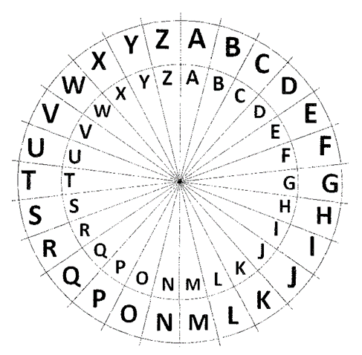

Encryption is used to convert information or data into a form that cannot easily be understood unless you have the key or authority to read it.

One famous and easy type of encryption system is the Caesar Cipher. It is not secure enough to be used for Cybersecurity today but does give a simple example of how information can be hidden or disguised from people not authorised to view it.

Try it!

Decrypt the following sentence: IDVW DQG WKH FXULRXV (You’ll need the key which is 3)

Start by finding the first letter on the inner circle: “I”

Count three places above the top left corner of “I”.

The letter is “F”.

Now do the same with “D”. You will get “A”

Continue until you have decoded every letter.

Did you answer: fast and the curious?

Make your own Caesar Cipher with two paper plates and simply rotate one on the other.

Page 35

Transmission medium

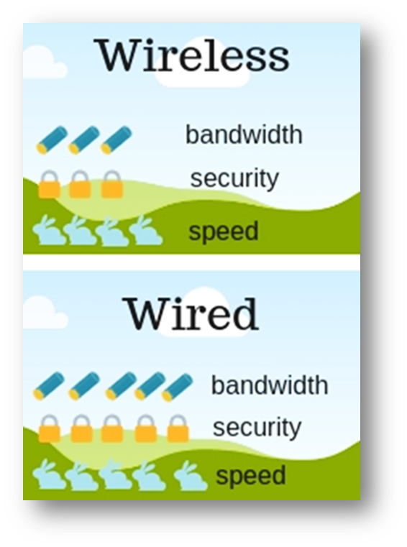

Study the above infographic and write a paragraph below that summarises your findings:

**Page 37**

Activity – Transmission Mediums

Work in pairs to research one of the transmission mediums below.

* Coaxial
* Satellite
* Fibre Optic
* Wi-Fi Bluetooth
* Radio Ethernet

Use [Canva](https://www.canva.com/) (online infogram software) to design and create an infographic card that scores each category out of 5 for the following.

* Speed:
* Cost:
* Bandwidth:
* Distance:
* Mobility:

Use all 7 infographic cards to design and play a trading card game (like Top Trumps, Yu-Gi-oh or Pokémon) that uses the score of each category to play. For example: Does Satellite beat Bluetooth for distance? Use the chart below to record your results.

| Blank | Coaxial | Satellite | Fibre Optic | Wi-Fi | Bluetooth | Radio | Ethernet |
| --- | --- | --- | --- | --- | --- | --- | --- |
| Coaxial | Blank |  |  |  |  |  |  |
| Satellite |  | Blank |  |  |  |  |  |
| Fibre Optic |  |  | Blank |  |  |  |  |
| Wi-Fi |  |  |  | Blank |  |  |  |
| Bluetooth |  |  |  |  | Blank |  |  |
| Radio |  |  |  |  |  | Blank |  |
| Ethernet |  |  |  |  |  |  | Blank |

My transmission medium infographic

Insert your infographic here

Page 40

Flowcharts

The symbols below can be used to describe (or model) Information Systems. They are useful to help visually explain how data moves through a system. (Like the Anki Oracle Hack).The symbols are connected by lines which represent the data flow.

Extension work – make a flowchart to describe the Anki Oracle hack.

[Flowchart Symbols and Notation](https://www.lucidchart.com/pages/flowchart-symbols-meaning-explained?a=0)

Note – process, start/end and decision symbols are also used to describe algorithms. (Step by step instructions)

| Symbol | Name | Description |
| --- | --- | --- |
| Process Flowchart Symbol | Process symbol | Also known as an ‘action symbol,’ this shape represents a process, action, or function. It’s the most widely-used symbol in flowcharting. |
| Start/End Flowchart Symbol | Start/End symbol | Also known as the ‘terminator symbol,’ this symbol represents the start points, end points, and potential outcomes of a path. Often contains ‘start’ or ‘end’ within the shape. |
| Document Flowchart Symbol | Document symbol | Represents the input or output of a document, specifically. Examples of and input are receiving a report, email, or order. Examples of an output using a document symbol include generating a presentation, memo, or letter. |
| Decision Flowchart Symbol | Decision symbol | Indicates a question to be answered – usually yes/no or true/false. The flowchart path may then split off into different branches depending on the answer or consequences thereafter. |
| Connector Flowchart Symbol | Connector symbol | Usually used within more complex charts, this symbol connects separate elements across one page. |
| Off-page Connector Flowchart Symbol | Off-Page Connector/ Link symbol | Frequently used within complex charts, this symbol connects separate elements across multiple pages with the page number usually placed on or within the shape for easy reference. |
| Input/Output Flowchart Symbol | Input/ Output symbol | Also referred to as the ‘data symbol,’ this shape represents data that is available for input or output as well as representing resources used or generated. While the paper tape symbol also represents input/output, it is outdated and no longer in common use for flowchart diagramming. |
| Comment Flowchart Symbol | Comment/ Note symbol | Placed along with context, this symbol adds needed explanation or comments within the specified range. It may be connected by a dashed line to the relevant section of the flowchart as well. |
| merge symbol | Merge symbol | Combines multiple paths to become one. |
| preparation symbol | Preparation symbol | Differentiates between steps that prepare for work and steps that actually do work. It helps introduce the setup to another step within the same process. |
| Manual Operation Symbol | Manual Operation Symbol | Indicates a step that must be done manually, not automatically. |
| Hard Disk Symbol | Hard Disk Symbol | Indicates where data is stored within a hard drive, also known as direct access storage. |
| Telecommunication Link | Telecommunication Link |  |
|  | Online Input |  |
| Online Display | Online Display |  |

Click on the link or copy and paste it into your browser to research and complete the remaining three symbols.

Page 42

Activity 1

Using the highlighted symbols above create a flow chart explaining how to create a piece of butter and vegemite toast.

You will need to make decisions on how toasted the bread is, how much butter and vegemite is applied, whether crusts stay on or off and if the toast is to be cut.

Activity 2

Create a flowchart for another process in your life. For example, travelling to school, two sets of traffic lights at an intersection and so on