**Report on**

**How to Make a Creative Report**

**Prepared by:**

**Robert Mill**

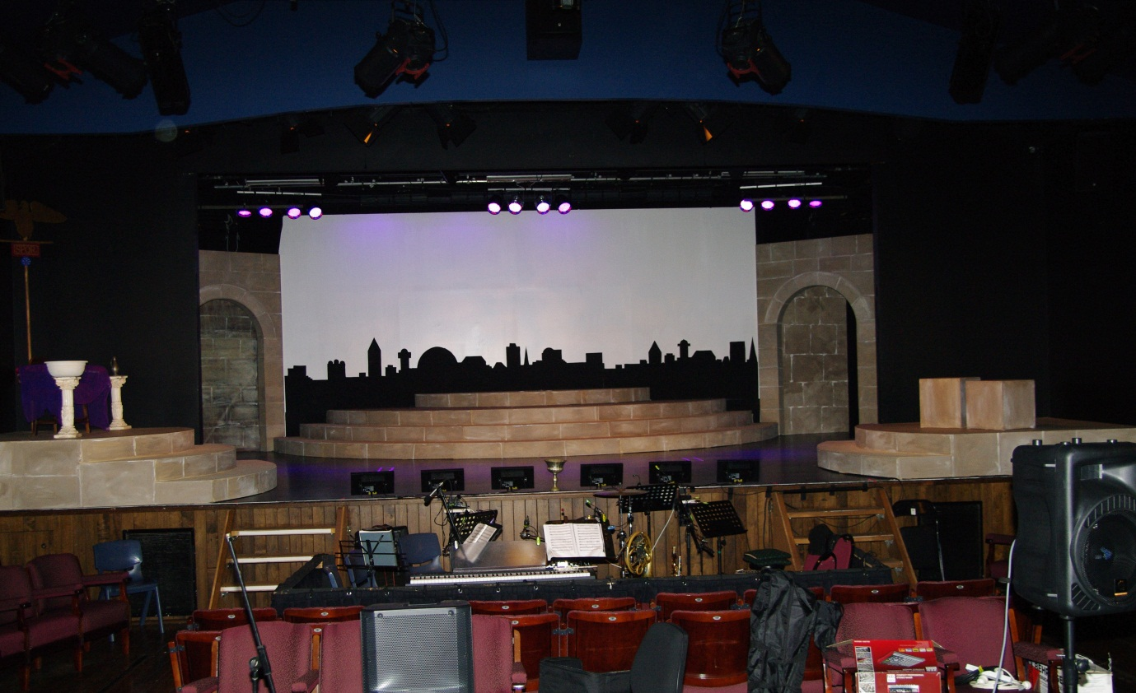

**Table of Contents**

|  |  |
| --- | --- |
| Table of Contents | This Page |
| Use of a Footer | 3 |
| Page Headings – an Essential | 4 |
| Page Content | 5 |
| Images | 6 |
| Visually Displayed Reports | 7 |
| Fonts, Line Spacing – making for better readability | 8 |
| Watermarks | 9 |
| Spelling and Type Check | 10 |
| Bibliography | 11 |

**A Table of Contents is absolutely essential for any report.**

* It must be accurate to the report’s pages.
* The TOC title should match (or be a summarised match) of each of the report pages header.
* Check the TOC against the final document after completion.

**Report Layout Essentials**

**1/. A Footer**

**Use a footer on each page with page numbering.**

* Ensure the footer used incorporates page numbering (essential for any report, alleviates guessing which page is which).
* Include your name in the footer, even though it appears on the Title Page.
* Ensure the footer’s font is not the default font, but the same font as the page font.

**2/. Page Headings**

* These are absolutely essential to a good report.
* They should be a larger font than the page content.
* 18pt font height is good.
* They must conform to the TOC reference index , but can be extended to cover the full header reference name.

**3/. Page Content**

**It is absolutely essential that you use your own words.**

* Read from the references you use, copy and paste the content in by all means, but then summarise in your own words.
* Do not copy/paste content as a whole and expect it to be passed as your own work.
* There are too many traps to fall into when only copy/paste.
* Summarise into bullet point or short one sentence per paragraph format.
* Do not use lengthy chunks as one paragraph, it is just too hard to read and absorb.
* Think about the page layout
* Break the page up, so that each main point is easily followed.
* Use sub-bullet points to break-up the content .
* A report page does not have to be filled up.
* Never group two headings on the one page.
* See the example below.

**4/. Use of Images**

**The use of images in a report to highlight pages is highly recommended.**

* We no longer want to read pages upon pages of boring ‘words’.
* We need ‘life’ in the pages and that’s images.
* But that does not mean a page of images!
* Keep it subtle and to the point.

**Assume the topic here was stage design and seating layouts.**

This type of image directly shows a concert hall, it’s seating and lighting aspects.

* It is also a high quality image.



**Handy Hint:**

When inserting a picture form a file in Word, use the Text Wrapping Tight command, so that you can ‘dock’ the image, rather than have it take over the page or document.

* Select the image, use the commands: Picture Tools, Format, Wrap Picture, Tight.
* You can resize the image, but ensure it does not pixelate if made larger. No one wants to view a burry image!

**5/. Visually Displayed Reports**

**Assume your report maybe displayed on a screen as well or instead of print.**

* This maybe done as a word document display.
* Or a converted Acrobat .pdf file.
* It is becoming more common to ‘screen’ rather than print many copies of a report.
* Make your report interesting and colourful.
* But do not overdo it!
* A header 18pt
* For visual reports, you may consider **font colours**.
* But do not use the rainbow type effect.
* The suggestion (if you want to use a colour scheme) would be:
* Headings in one consistent colour throughout.
* Black text as main content.
* Word Art
  + Avoid it like the plague!
* Scripted fonts – totally avoid, as people need to read your report. Worse than illegible writing!

**6/. Fonts, Non-use of Word Art and Line Spacing for better readability**

**So important in anything your produce, is a readable font.**

* Forget hard to read fonts, such as this one, or this one, , or this one.
* Never use all CAPS fonts.
* Never, never use scripted fonts, such as this one.
* Do not challenge your report readers to guess what you have written.
* Also take care with font height.
* A good font height is 11-12pt
* A header 18pt
* Line Spacing.
  + This should be 1.5cm, as opposed to the default 1.15 (tight) or double (too airy).

**7/. Use of Watermarks**

**These are non-essential, but strategically worded may help in your design layout.**

* Don’t be too wordy in your watermark.
* Or you may use an image as your watermark!
* If an image is used, reduce the opacity to have the watermark drop back in the background, rather than overtake the content.

**8/. Spelling and Typo Check**

**To make your report work for you and not distract your audience ensure you di the basic skills.**

* Proof read your report.
* Do a spell check.
* Do a typo check.

**9/. Bibliography/Referencing**

**This is simply where you acknowledge where you resourced information from.**

* www.rmwebed.com.au/ent2010/source/ind_bodies. (this link is no longer available).
* www.google.com.au/images/stagecurtains.
* Main content used (and modified) in pages 7 – 14: <http://libweb.surrey.ac.uk/library/skills/writing%20Skills%20Leicester/page_75.htm>

What is a report?

A report is written for a clear purpose and to a particular audience. Specific information and evidence are presented, analysed and applied to a particular problem or issue. The information is presented in a clearly structured format making use of sections and headings so that the information is easy to locate and follow.

When you are asked to write a report you will usually be given a report brief which provides you with instructions and guidelines.

The report brief may outline the purpose, audience and problem or issue that your report must address, together with any specific requirements for format or structure. This guide offers a general introduction to report writing; be sure also to take account of specific instructions provided by your supervisor.

## What makes a good report?

Two of the reasons why reports are used as forms of written assessment are:

* to find out what you have learned from your reading, research or experience;
* to give you experience of an important skill that is widely used in the work place.

An effective report presents and analyses facts and evidence that are relevant to the specific problem or issue of the report brief. All sources used should be acknowledged and referenced throughout, in accordance with the preferred method of your department/university. The style of writing in a report is usually less discursive than in an essay, with a more direct and economic use of language. A well written report will demonstrate your ability to:

* understand the purpose of the report brief and adhere to its specifications;
* gather, evaluate and analyse relevant information;
* structure material in a logical and coherent order;
* present your report in a consistent manner according to the instructions of the report brief;
* make appropriate conclusions that are supported by the evidence and analysis of the report;

Make thoughtful and practical recommendations where required.

## The structure of a report

The main features of a report are described below to provide a general guide. These should be used in conjunction with the instructions or guidelines provided by your department.

**Title Page**

This should briefly but explicitly describe the purpose of the report (if this is not obvious from the title of the work). Other details you may include could be your name, the date and for whom the report is written.

*Geology of the country around Beacon Hill, Leicestershire  
Angus Taylor  
2 November 2004*

**(Example of a title page)**

**Terms of Reference**

Under this heading you could include a brief explanation of who will read the report (audience) why it was written (purpose) and how it was written (methods). It may be in the form of a subtitle or a single paragraph.

*A report submitted in fulfilment of the requirements for Course GL456, Department of Geology, University of Leicester.*

**(Example of terms of reference)**

**Summary (Abstract)**

The summary should briefly describe the content of the report. It should cover the aims of the report, what was found and what, if any, action is called for. Aim for about 1/2 a page in length and avoid detail or discussion; just outline the main points. Remember that the summary is the first thing that is read. It should provide the reader with a clear, helpful overview of the content of the report.

*Exposure of rocks belonging to the Charnian Supergroup (late Precambrian) were examined in the area around Beacon Hill, north Leicestershire. This report aims to provide details of the stratigraphy at three sites - Copt Oak, Mount St. Bernard Abbey and Oaks in Charnwood. It was observed that at each of these sites, the Charnian Supergroup consists mainly of volcaniclastic sediments (air-fall and ash-flow tuffs) interbedded with mudstones and siltstones. These rocks show features that are characteristic of deposition in shallow water on the flanks of a volcano (e.g. welding and alteration of ignimbrites). Further studies are required to understand depositional mechanisms and to evaluate the present-day thickness of individual rock units.*

**(Example of a summary (abstract))**

**Contents (Table of Contents)**

The contents page should list the different chapters and/or headings together with the page numbers. Your contents page should be presented in such a way that the reader can quickly scan the list of headings and locate a particular part of the report. You may want to number chapter headings and subheadings in addition to providing page references. Whatever numbering system you use, be sure that it is clear and consistent throughout.

**Introduction**

The introduction sets the scene for the main body of the report. The aims and objectives of the report should be explained in detail. Any problems or limitations in the scope of the report should be identified, and a description of research methods, the parameters of the research and any necessary background history should be included.

In some reports, particularly in science subjects, separate headings for **Methods** and **Results** are used prior to the main body (**Discussion**) of the report as described below.

**Methods**

Information under this heading may include: a list of equipment used; explanations of procedures followed; relevant information on materials used, including sources of materials and details of any necessary preparation; reference to any problems encountered and subsequent changes in procedure.

**Results**

This section should include a summary of the results of the investigation or experiment together with any necessary diagrams, graphs or tables of gathered data that support your results. Present your results in a logical order without comment. Discussion of your results should take place in the main body (**Discussion**) of the report.

**Discussion**

The main body of the report is where you discuss your material. The facts and evidence you have gathered should be analysed and discussed with specific reference to the problem or issue. If your discussion section is lengthy you might divide it into section headings. Your points should be grouped and arranged in an order that is logical and easy to follow. Use headings and subheadings to create a clear structure for your material. Use bullet points to present a series of points in an easy-to-follow list. As with the whole report, all sources used should be acknowledged and correctly referenced.

**Conclusion**

In the conclusion you should show the overall significance of what has been covered. You may want to remind the reader of the most important points that have been made in the report or highlight what you consider to be the most central issues or findings. However, no new material should be introduced in the conclusion.

**Appendices**

Under this heading you should include all the supporting information you have used that is not published. This might include tables, graphs, questionnaires, surveys or transcripts. Refer to the appendices in the body of your report.

In order to assess the popularity of this change, a questionnaire (Appendix 2) was distributed to 60 employees. The results (Appendix 3) suggest the change is well received by the majority of employees.

**Bibliography**

Your bibliography should list, in alphabetical order by author, all published sources referred to in your report. There are different styles of using references and bibliographies. Texts which you consulted but did not refer to directly could be grouped under a separate heading such as 'Background Reading' and listed in alphabetical order using the same format as in your bibliography.

**Acknowledgements**

Where appropriate you may wish to acknowledge the assistance of particular organisations or individuals who provided information, advice or help.

**Glossary of Technical Terms**

It is useful to provide an alphabetical list of technical terms with a brief, clear description of each term. You can also include in this section explanations of the acronyms, abbreviations or standard units used in your report.

**You will not necessarily be required to use all of the headings described above, nor will they necessarily be in the order given here. Check your departmental guidelines or instructions.**

Writing the report: the essential stages

All reports need to be clear, concise and well structured. The key to writing an effective report is to allocate time for planning and preparation. With careful planning, the writing of a report will be made much easier. The essential stages of successful report writing are described below. Consider how long each stage is likely to take and divide the time before the deadline between the different stages. Be sure to leave time for final proof reading and checking.

**Stage One: Understanding the report brief**

This first stage is the most important. You need to be confident that you understand the purpose of your report as described in your report brief or instructions. Consider who the report is for and why it is being written. Check that you understand all the instructions or requirements, and ask your tutor if anything is unclear.

**Stage Two: Gathering and selecting information**

Once you are clear about the purpose of your report, you need to begin to gather relevant information. Your information may come from a variety of sources, but how much information you will need will depend on how much detail is required in the report. You may want to begin by reading relevant literature to widen your understanding of the topic or issue before you go on to look at other forms of information such as questionnaires, surveys etc. As you read and gather information you need to assess its relevance to your report and select accordingly. Keep referring to your report brief to help you decide what is relevant information.

**Stage Three: Organising your material**

Once you have gathered information you need to decide what will be included and in what sequence it should be presented. Begin by grouping together points that are related. These may form sections or chapters. Remember to keep referring to the report brief and be prepared to cut any information that is not directly relevant to the report. Choose an order for your material that is logical and easy to follow.

**Stage Four: Analysing your material**

Before you begin to write your first draft of the report, take time to consider and make notes on the points you will make using the facts and evidence you have gathered. What conclusions can be drawn from the material? What are the limitations or flaws in the evidence? Do certain pieces of evidence conflict with one another? It is not enough to simply present the information you have gathered; you must relate it to the problem or issue described in the report brief.

**Stage Five: Writing the report**

Having organised your material into appropriate sections and headings you can begin to write the first draft of your report. You may find it easier to write the summary and contents page at the end when you know exactly what will be included. Aim for a writing style that is direct and precise. Avoid waffle and make your points clearly and concisely. Chapters, sections and even individual paragraphs should be written with a clear structure. The structure described below can be adapted and applied to chapters, sections and even paragraphs.

* **Introduce** the main idea of the chapter/section/paragraph
* **Explain** and expand the idea, defining any key terms.
* **Present** relevant evidence to support your point(s).
* **Comment** on each piece of evidence showing how it relates to your point(s).
* **Conclude** your chapter/section/paragraph by either showing its  
  significance to the report as a whole or making a link to the next chapter/section/paragraph.

**Stage Six: Reviewing and redrafting**

Ideally, you should leave time to take a break before you review your first draft. Be prepared to rearrange or rewrite sections in the light of your review. Try to read the draft from the perspective of the reader. Is it easy to follow with a clear structure that makes sense? Are the points concisely but clearly explained and supported by relevant evidence? Writing on a word processor makes it easier to rewrite and rearrange sections or paragraphs in your first draft. If you write your first draft by hand, try writing each section on a separate piece of paper to make redrafting easier.

**Stage Seven: Presentation**

Once you are satisfied with the content and structure of your redrafted report, you can turn your attention to the presentation. Check that the wording of each chapter/section/subheading is clear and accurate. Check that you have adhered to the instructions in your report brief regarding format and presentation. Check for consistency in numbering of chapters, sections and appendices. Make sure that all your sources are acknowledged and correctly referenced. You will need to proof read your report for errors of spelling or grammar. If time allows, proof read more than once. Errors in presentation or expression create a poor impression and can make the report difficult to read.

## Feedback

Any feedback from tutors on returned work can be used to create a checklist of key points to consider for your next report. Identify priority areas for attention and seek out further information and advice. Speak to your tutor or an adviser from the Student Learning Centre. Used in this way, feedback from tutors can provide a useful tool for developing and improving your writing skills.